- Create an algorithm and a flowchart that will accept/read two numbers and then display the bigger number.

Algorithm:

Step 1: Start
Step 2: Enter two numbers
Step 3: If (n1 > n2) display n1.
Step 4: Else display “n2”
Step 5: Stop

Flowchart:

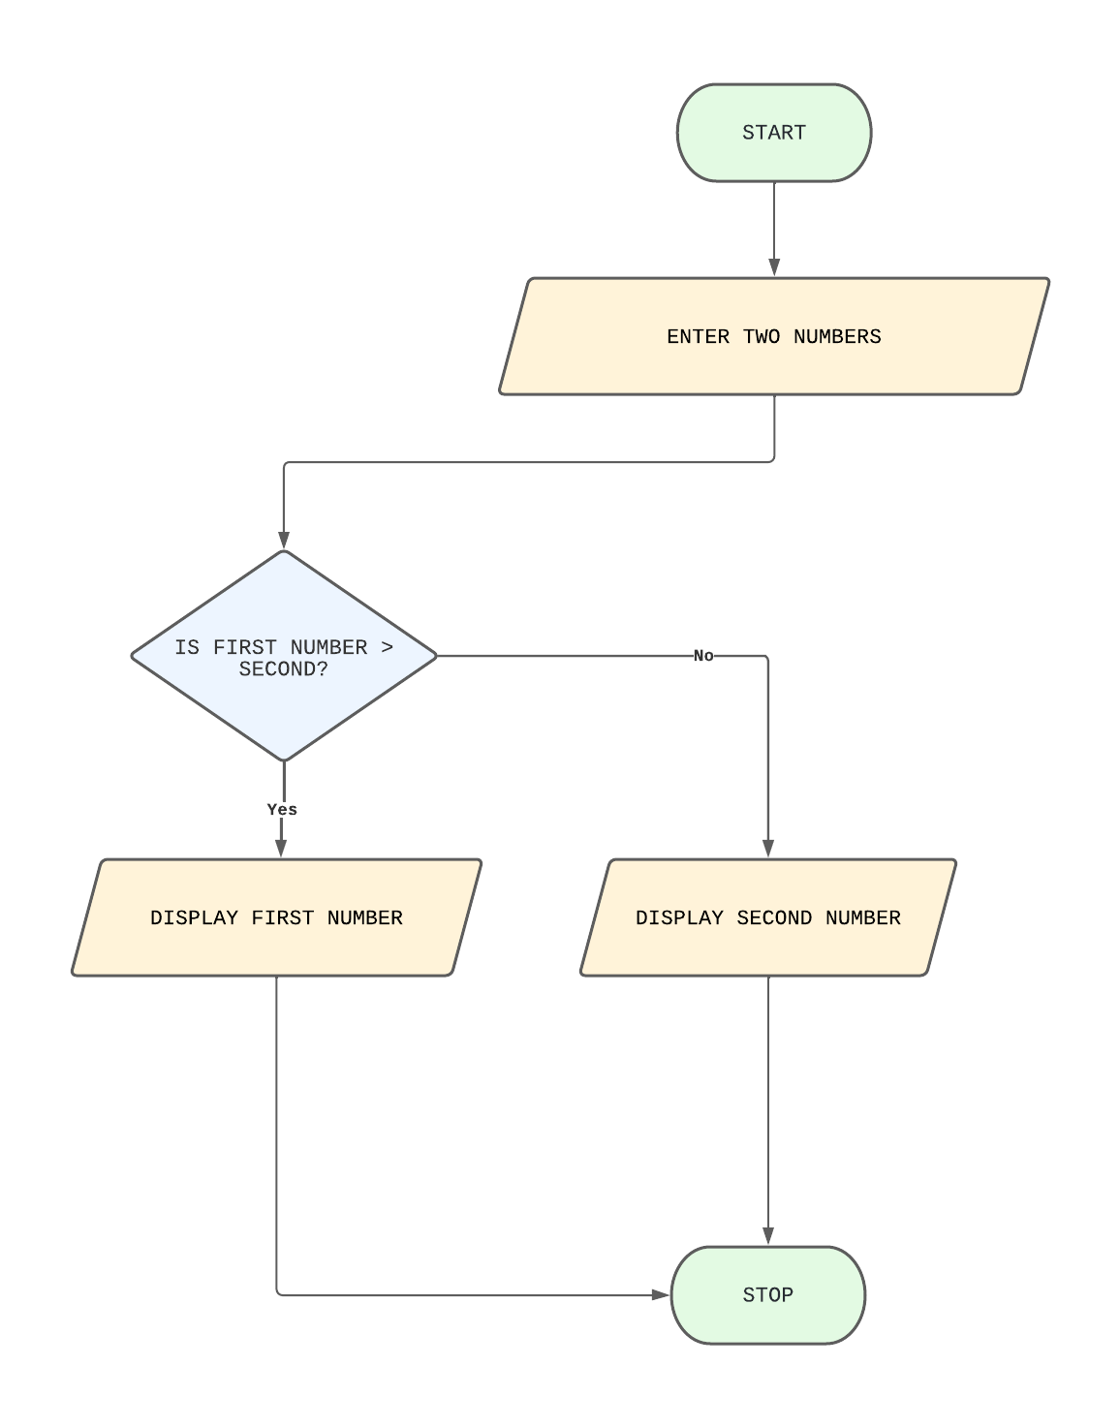

Java Code:

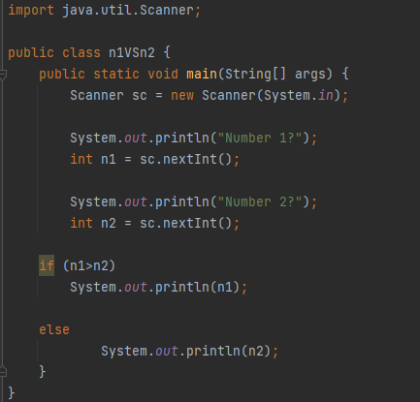

Output:

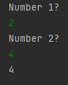

- Create an algorithm and a flowchart that will compute the area of a circle.

ALGORITHM:

Step 1: Start
Step 2: Enter the radius(r) of the circle
Step 3: Area of the circle is PI * radius * radius (area = PI * r * r)
Step 4: Display the area of the circle
Step 5: Stop

FLOWCHART:

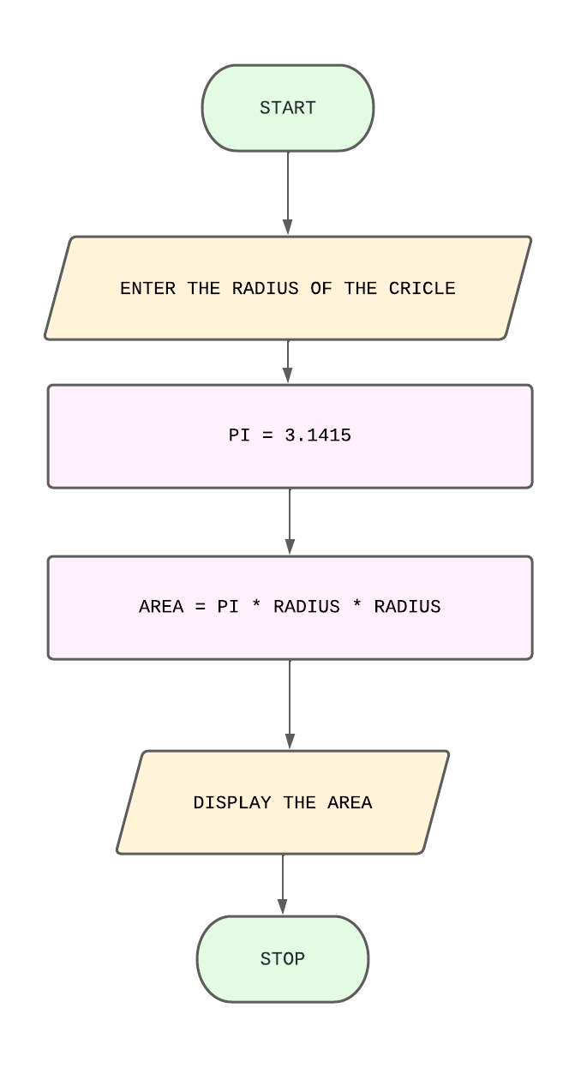
JAVA CODE:

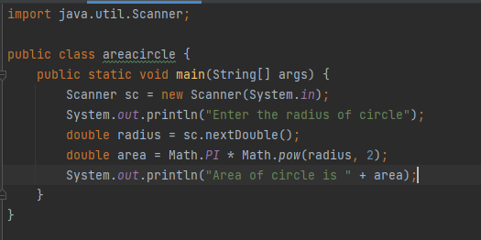

OUTPUT:

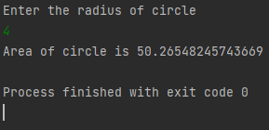

- Create an algorithm and a flowchart that will compute the sum of two numbers. If the sum is below or equal to twenty, two numbers will be entered again. If the sum is above 20, it will display the sum.

ALGORITHM:

Step 1: Start
Step 2: Enter two numbers
Step 3: Set Sum to num1 + num2
Step 4: If (sum <= 20); Go to Step 2
Step 5: Else display the sum
Step 6: Stop

FLOWCHART:

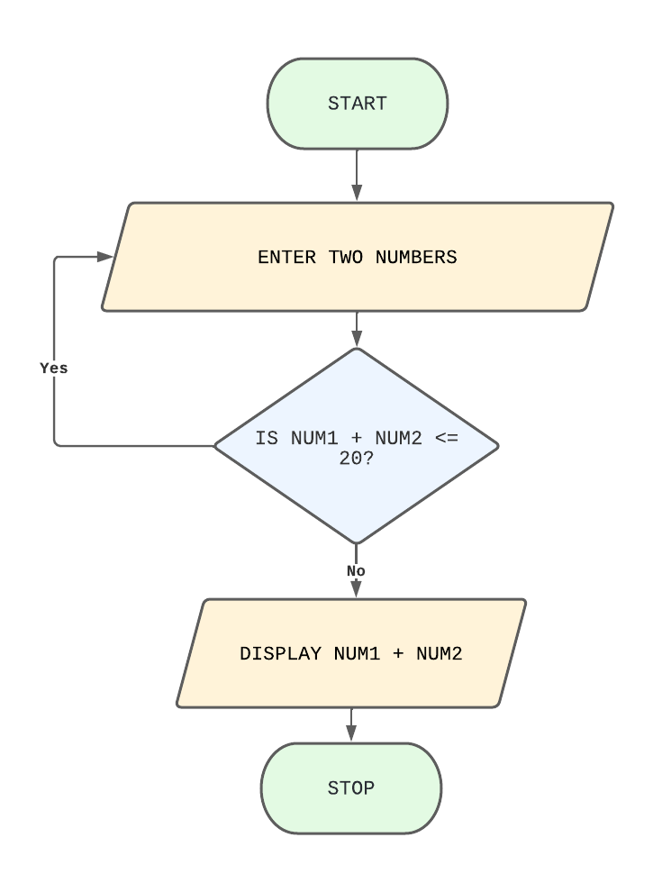

JAVA CODE:

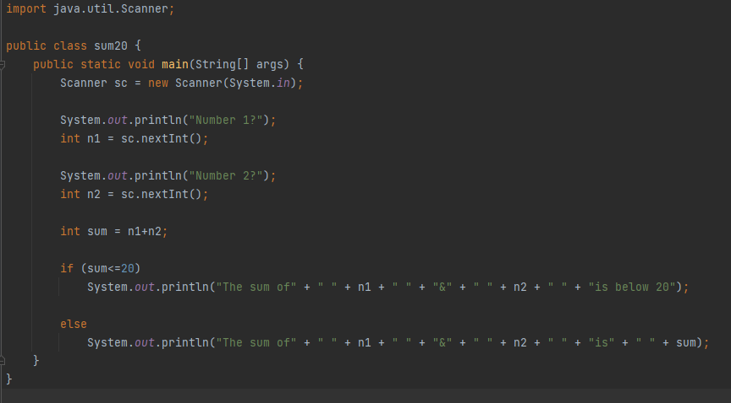

OUTPUT:

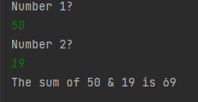

- Create an algorithm and a flowchart that will output the largest number among the three numbers.

ALGORITHM:

Step 1: Start
Step 2: Enter three numbers
Step 3: if (num1 >= num2 and num1 >= num3) display num1
Step 4: if (num2 >= num1 and num2 >= num3) display num2
Step 5: else display num3
Step 6: Stop

FLOWCHART:

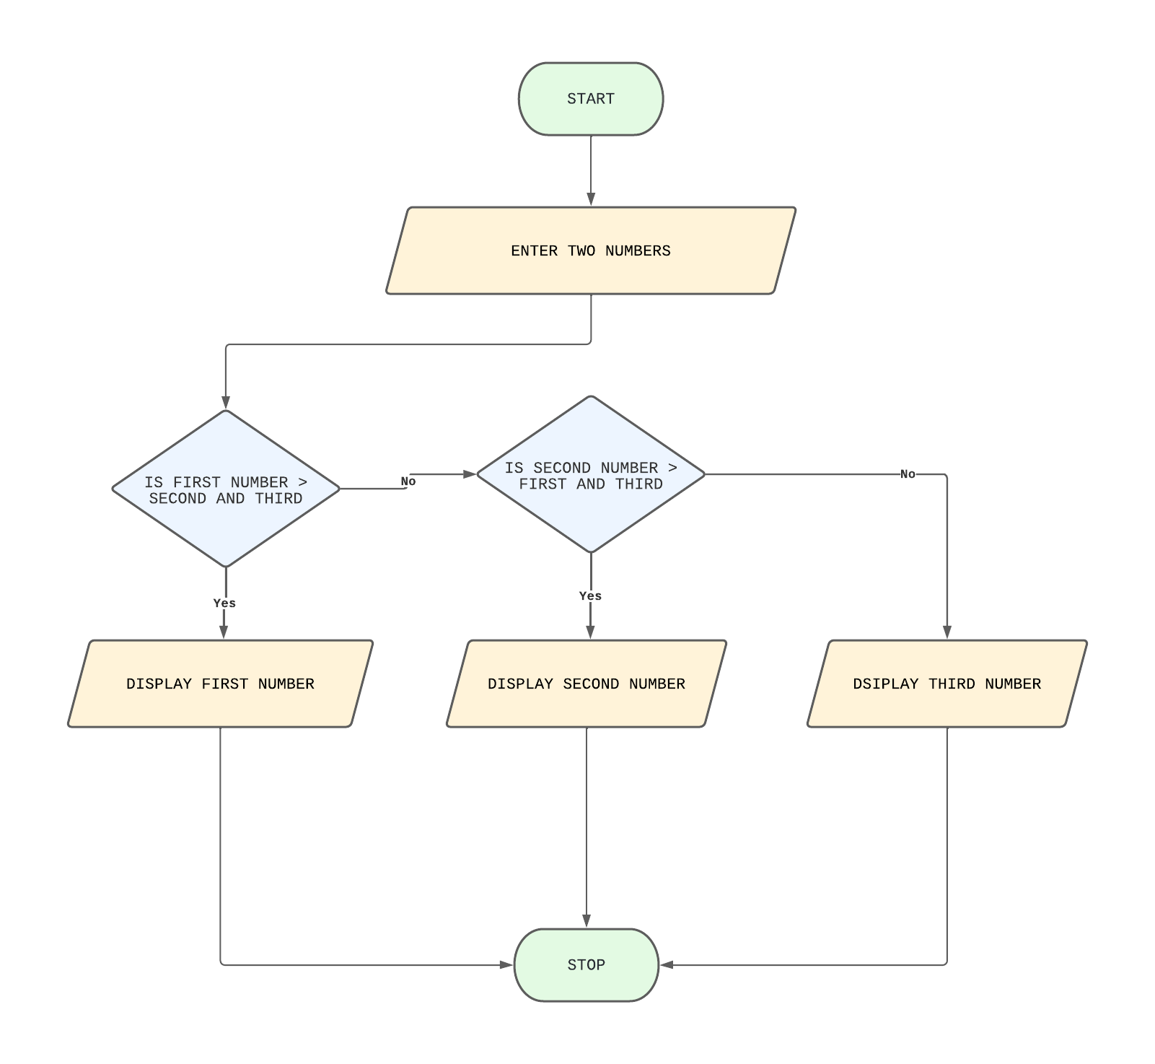

JAVA CODE:

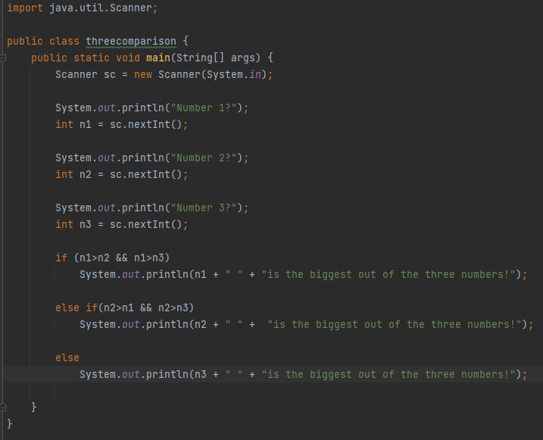

OUTPUT:

